Chapter 10, Problem 2.

Using Fig. 10.51, design a problem to help other students better understand nodal analysis.
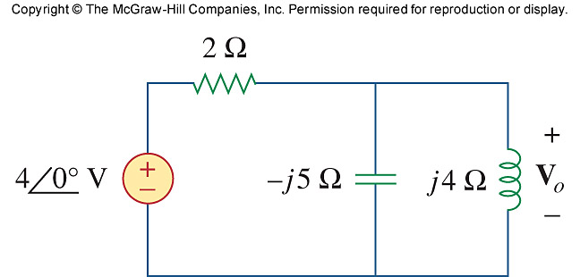

Figure 10.51
For Prob. 10.2.

